CLDV6212
POE Part 3
Qhawe Avumile Kheswa
ST10443092

Contents
Links 2
Screenshots 2
Technology Choices Table 4
Motivation of Azure Services Used 4
Alternative Azure Technologies 6
References 7

Links
GitHub Link https://github.com/VCPTA/bcad2-cldv6212-poe-submission-ST10443092.git
Application Link: https://st10443092-akf9cccygvcngjc8.eastus-01.azurewebsites.net/
Login details:
Customer email: qkheswa@gmail.com
Customer password:23
Manager Email: Manager@gmail.com
Manager password: 123

Screenshots
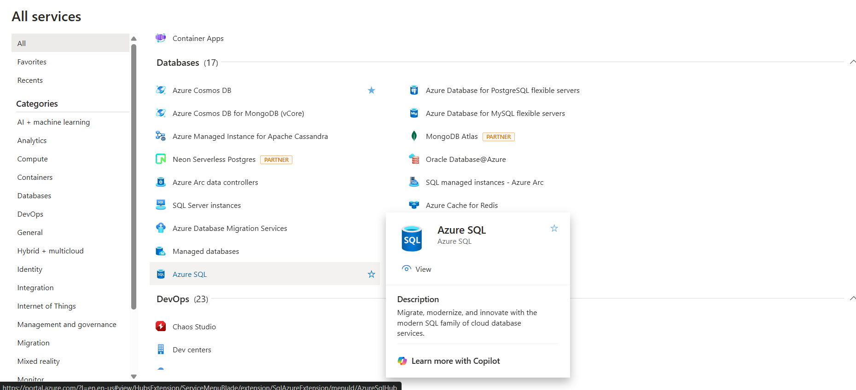
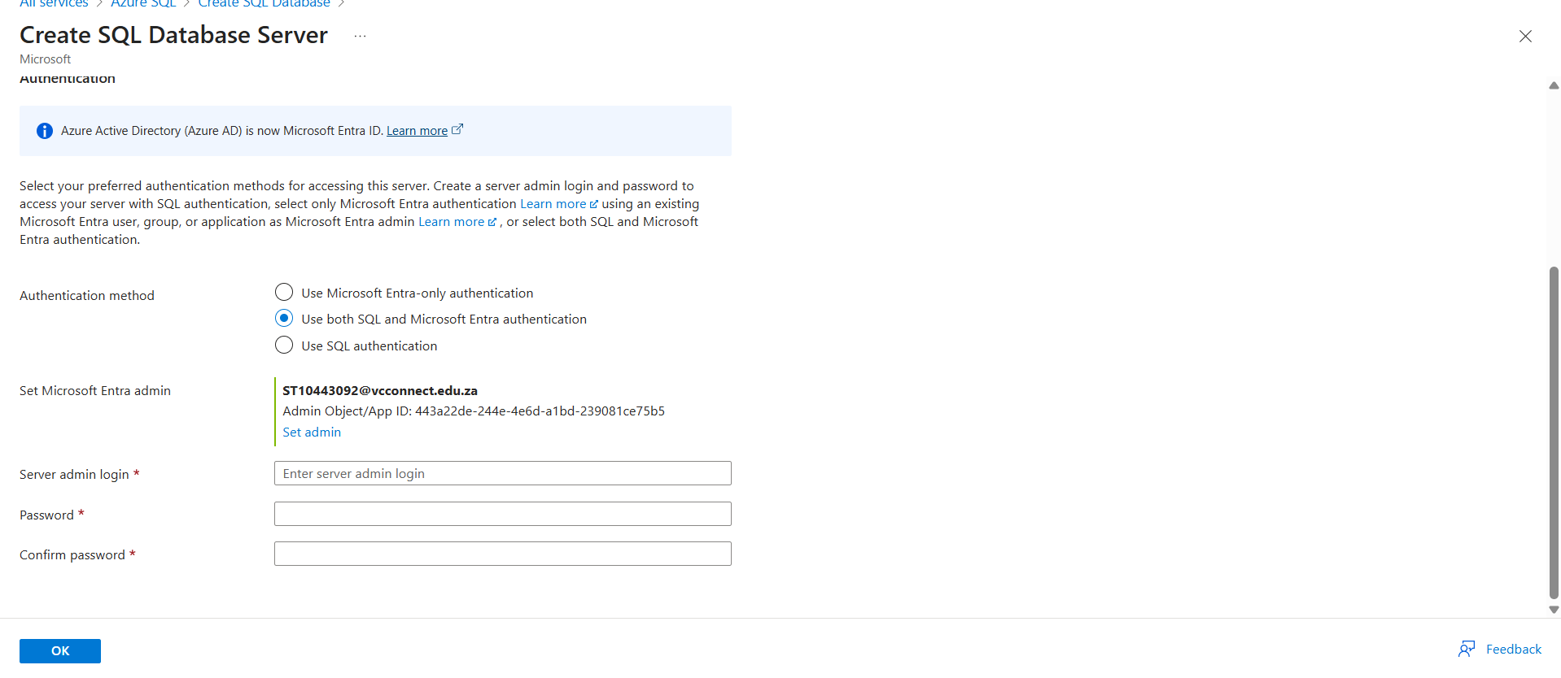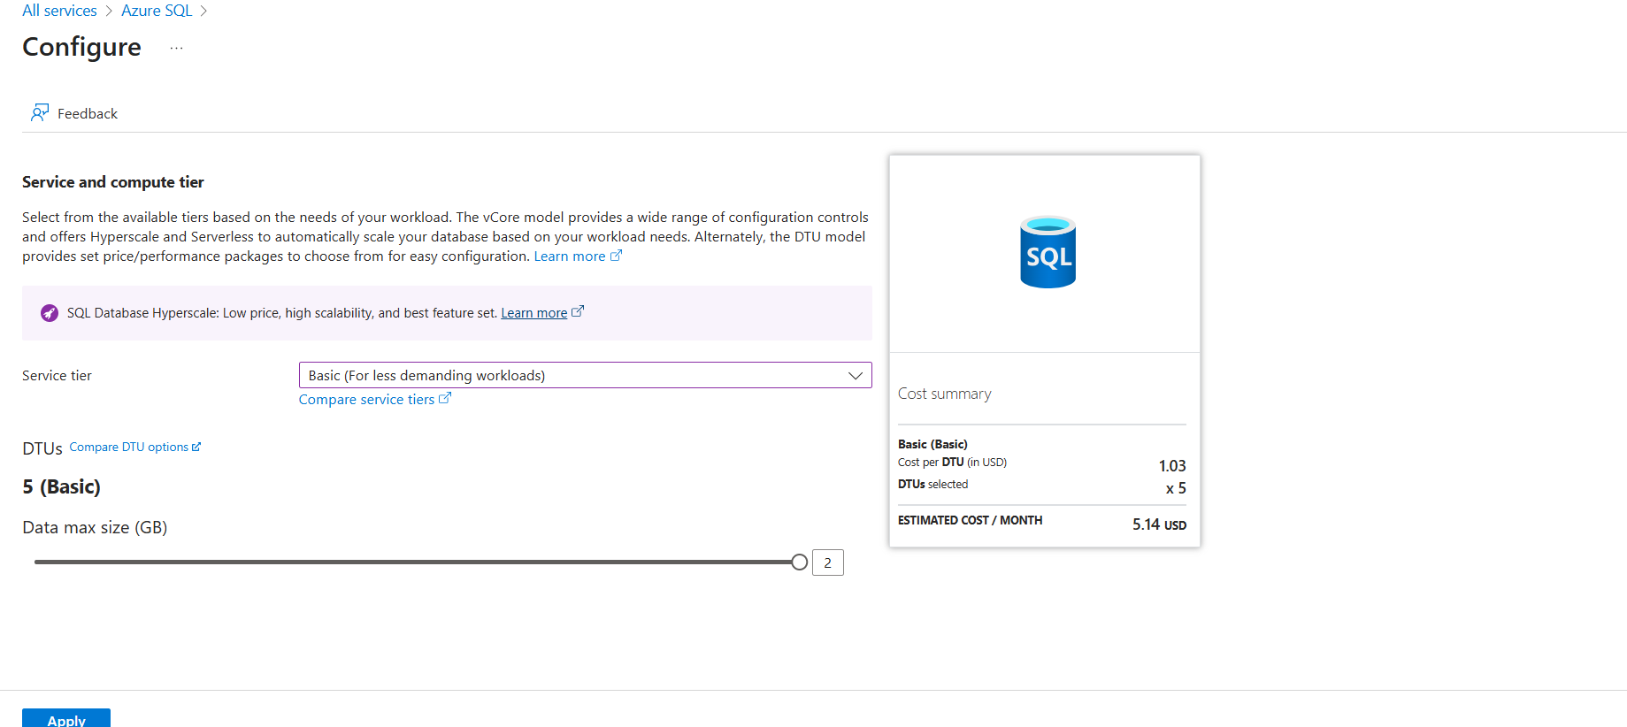
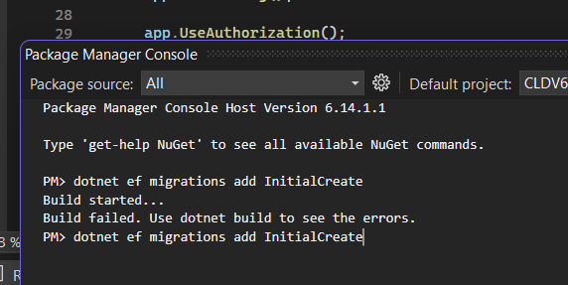

Technology Choices Table
Component / Service | Description / Purpose in the CR7 Store | Technology Choice (Compute / Storage / Networking / Identity, etc.) | Hosting Model (IaaS / PaaS / SaaS)
Azure App Service | Hosts the CR7 Store web application, Allows easy deployment and auto scaling. | Compute | PaaS
Azure SQL Database | Stores Customer information as well as employee information. This also has the login details | Data Storage (Relational DB) | PaaS
Azure Blob Storage | Stores product images (e.g., CR7 merchandise pictures), user uploads. Reduces load on the app. | Data Storage (Object Storage) | PaaS
Azure Key Vault | Secures sensitive data such as database connection strings and API keys. Prevents secrets from being stored in code. | Security / Identity | PaaS
Azure Blob | Stores unstructured data such as images | Storage | Paas
Azure Files | Stored PDF formatted files | Storage | PaaS

Motivation of Azure Services Used

Application Requirement: Hosting and running the web app.
Azure Service Used: Azure app service
Motivation:
The CR7 Store needed to be scalable and cost efficient in hosting an environment capable of running .NET web apps without manual maintenance. Azure App Service provides automatic scaling, deployment and load balancing. According to Rittinghouse and Ransome (2017), Platform-as-a-service models reduce the operational overhead of managing infrastructure allowing developers to focus on application features.

Application Requirement: Store and manage structured data (Customers and employee details) .
Azure Service Used: Azure SQL Database
Motivation:
The CR7 Store needed relational consistency to store customer and employee details and the azure sql does just that. Azure SQL enables secure, scalable and highly available data storage suitable for online communication (Microsoft, 2023).

Application Requirement: Store merchandise images and other static media
Azure Service Used: Azure Blob Storage
Motivation: The system required storage for potentially large unstructured data such as images. Azure Blob Storage is optimized for storing and serving large files at scale. Cloud object stores are ideal for web systems needing scalable, cost efficient access to media resources.

Application Requirement: Securely store sensitive configuration information (e.g., database keys)
Azure Service Used: Azure Key Vault
Motivation: Secure secret management was needed to protect private credentials that will be used by the application. Azure key vault provides centralized secret storage with strong encryption and access control. Fernandez (2019) emphasizes that secure key vaults systems reduce risk by preventing credential exposure in source code.

Application Requirement: Provide shared storage for product documents (Supplier Contracts).
Azure Service Used: Azure Files
Motivation: The CR7 Store administration required file storage accessible from both the application and local systems. Azure Files allows file shares to be mounted directly to applications or on-premises systems, making it suitable for shared asset editing and uploads. O’Reilly (2021), shared network file systems in the cloud offer seamless collaboration without needing local file servers.
Application Requirement: Handle asynchronous processing tasks, such as order confirmation notifications
Azure Service Used: Azure Queue Storage
Motivation: The store required background tasks processing to avoid delaying user interface delays when customers place an order. Azure queue storage allows reliable message queuing to detach the front end from the back end when processing tasks. Queue systems improve scalability and responsiveness by enabling synchronous processing cloud applications (Hameed, Khan and Shan, 2021).

Alternative Azure Technologies
Azure Service Used: Azure App Service
Alternative Azure Service: Azure Virtual Machine
Motivation: Azure VMs can also be used to host the store by providing full control of the server environment, operating system configuration and runtime. However this requires manual management of scaling, security, patches and updates making it more suitable for application that require custom configurations.
Azure Service Used: Azure SQL Database
Alternative Azure Service: Azure Database for MySQL
Motivation: Azure SQL Database for MySQL offers similar managed relational database experience as the azure sql database, but this uses the MySQL engine. This makes it suitable when developers prefer open-source environments. Azure MySQL ensure high availability and optimised performance for transactional apps (Microsoft, 2022).

Azure Service Used: Azure Queue Storage
Alternative Azure Service: Azure Service Bus
Motivation: Azure Service Bus Provides more advanced messaging capabilities such as ordering, scheduling and publish patterns this is useful for complex cloud workflows requiring guaranteed message delivery and coordination (Hameed, Khan and Shan, 2021).

Azure Service Used: Azure Blob storage
Alternative Azure Service: Azure Data Lake Storage Gen2
Motivation: Azure data lake storage gen2 build on blob storage by allowing hierarchical storage and deeper analytics capabilities. This would be beneficial if the store later expands to advanced reporting or machine learning workflows workflows (Al-Ruithe, Benkhelifa and Hameed, 2018).

References
Al-Ruithe, M., Benkhelifa, E. and Hameed, K. (2018) ‘Data Governance in Cloud Computing’, Journal of Cloud Computing, 7(1), pp. 1–22.
Fernandez, E.B. (2019) Security Patterns in Practice. Wiley.
Hameed, R., Khan, S. and Shan, R. (2021) ‘Cloud Identity Access Management in Modern Web Applications’, IEEE Access, 9, pp. 114955–114965.
Microsoft (2023) Azure SQL Database Documentation. Available at: https://learn.microsoft.com/azure/azure-sql/ (Accessed: 7 November 2025).
O’Reilly, M. (2021) Cloud Native Storage. O’Reilly Media.
Rittinghouse, J.W. and Ransome, J.F. (2017) Cloud Computing: Implementation, Management and Security. CRC Press.
Al-Ruithe, M., Benkhelifa, E. and Hameed, K. (2018) ‘Data Governance in Cloud Computing’, Journal of Cloud Computing, 7(1), pp. 1–22.
Hameed, R., Khan, S. and Shan, R. (2021) ‘Cloud Identity Access Management in Modern Web Applications’, IEEE Access, 9, pp. 114955–114965.
Microsoft (2022) Azure Database for MySQL Documentation. Available at: https://learn.microsoft.com/azure/mysql/ (Accessed: 7 November 2025).
Rittinghouse, J.W. and Ransome, J.F. (2017) Cloud Computing: Implementation, Management and Security. CRC Press.

